Batch: B2 Roll No.: 16010121200

Experiment No. 02

Grade: AA / AB / BB / BC / CC / CD /DD

Signature of the Staff In-charge with date

Title: Implementation of XOR Gate LOGIC using perceptron network. .
___________________________________________________________________________________
Objective: To implement classifier using multi-layer perceptron network for XOR logic of 2 inputs.
___________________________________________________________________________________
Expected Outcome of Experiment:

CO2: Analyze various neural network architectures ____________________________________________________________________________________
Books/ Journals/ Websites referred:

- J.S.R.Jang, C.T.Sun and E.Mizutani, “Neuro-Fuzzy and Soft Computing”, PHI, 2004, Pearson Education 2004.
- Davis E.Goldberg, “Genetic Algorithms: Search, Optimization and Machine Learning”, Addison Wesley, N.Y., 1989.
____________________________________________________________________________________
Pre Lab/ Prior Concepts:
- Perceptron Model
- Linear separability
- Design of Classifier using Multi-layer Perceptron model for XOR Gate logic with 2 inputs
(Ref. Zurada 4.1 page no `68)

Truth table for XOR logic
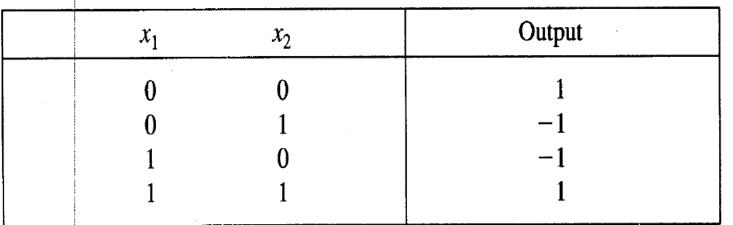

(Ref, Zurada Chapter 4 )

Perceptron (TLU #1 and TLU +2) for first layer using bipolar activation function
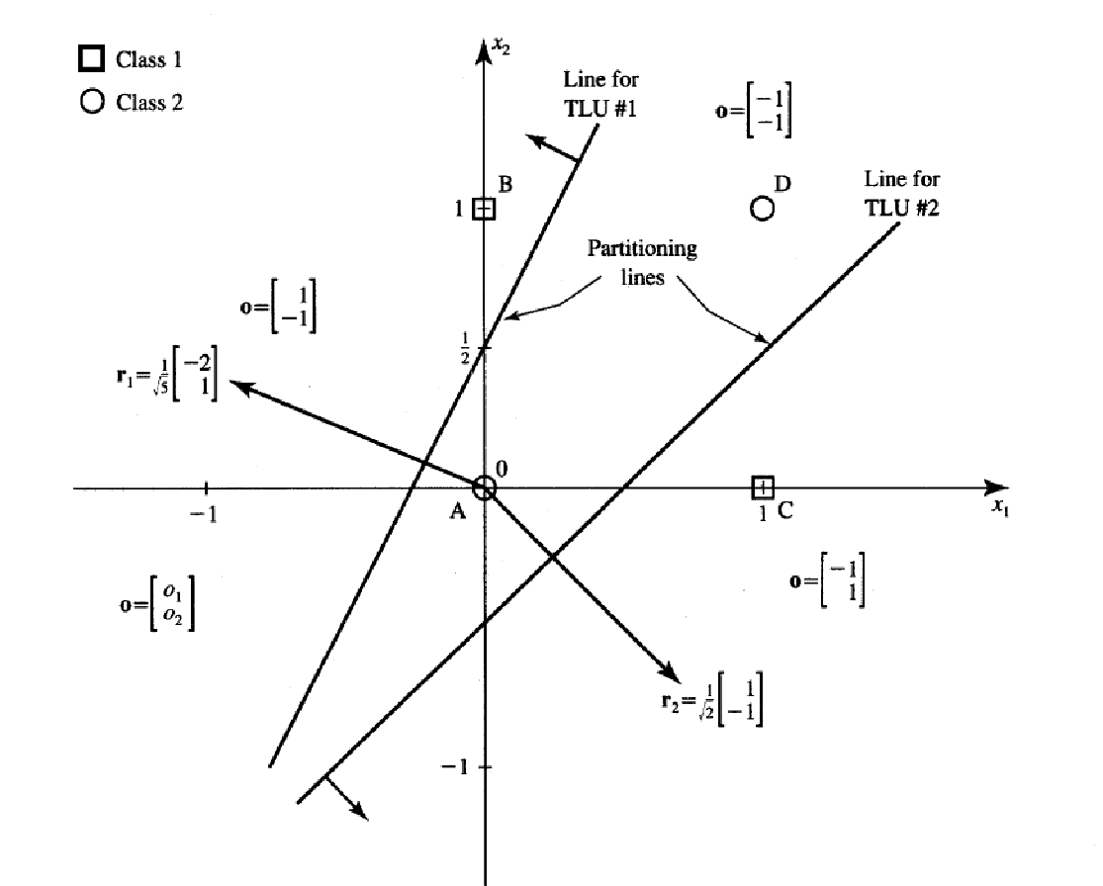

Two decision lines having equations using arbitrary selected partitioning as shown in above figure.
(Ref. Zurada Chapter 4)

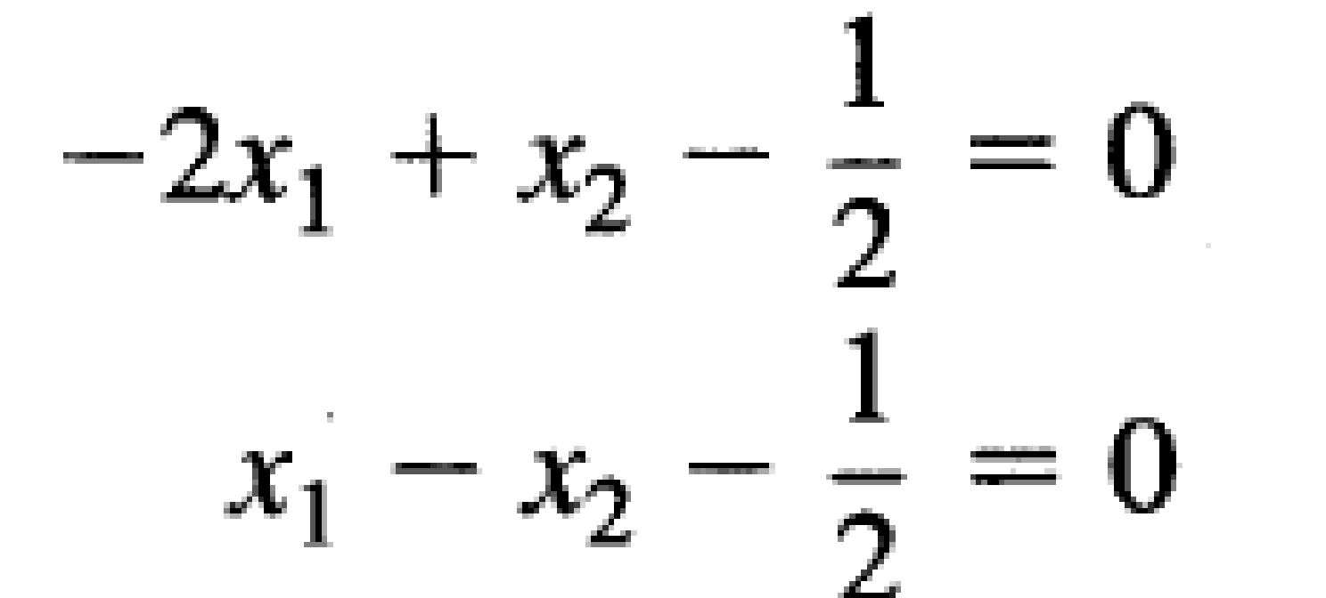

Mapping performed by first layer perceptron’s TLU#1 and TLU#2
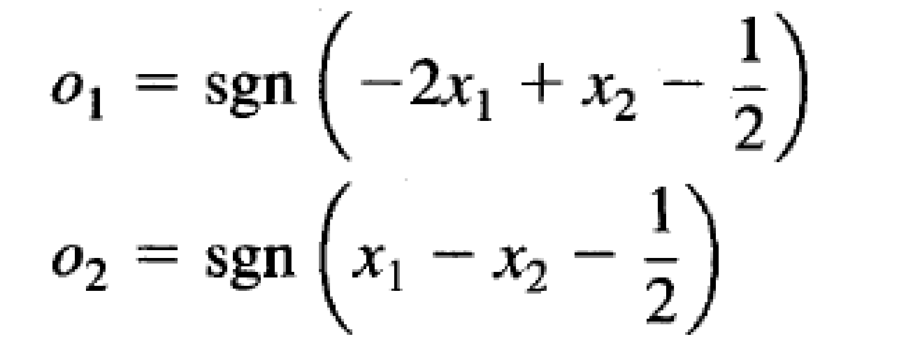

Final Output layer perceptron TLU#3
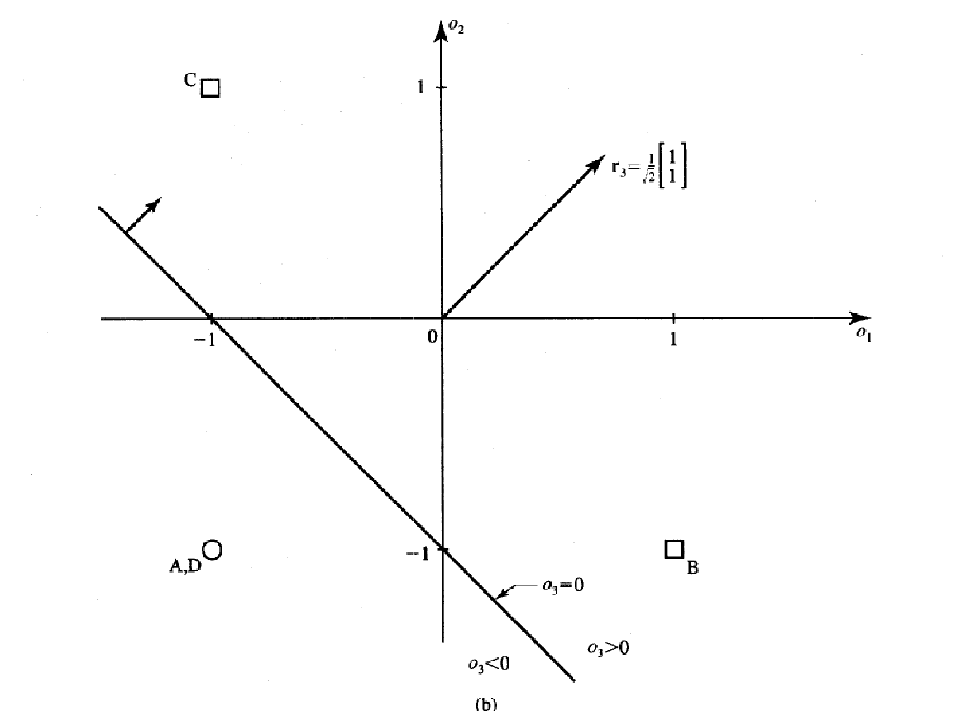

(Ref, Zurada Chapter 4 )

The decision line represents the equation
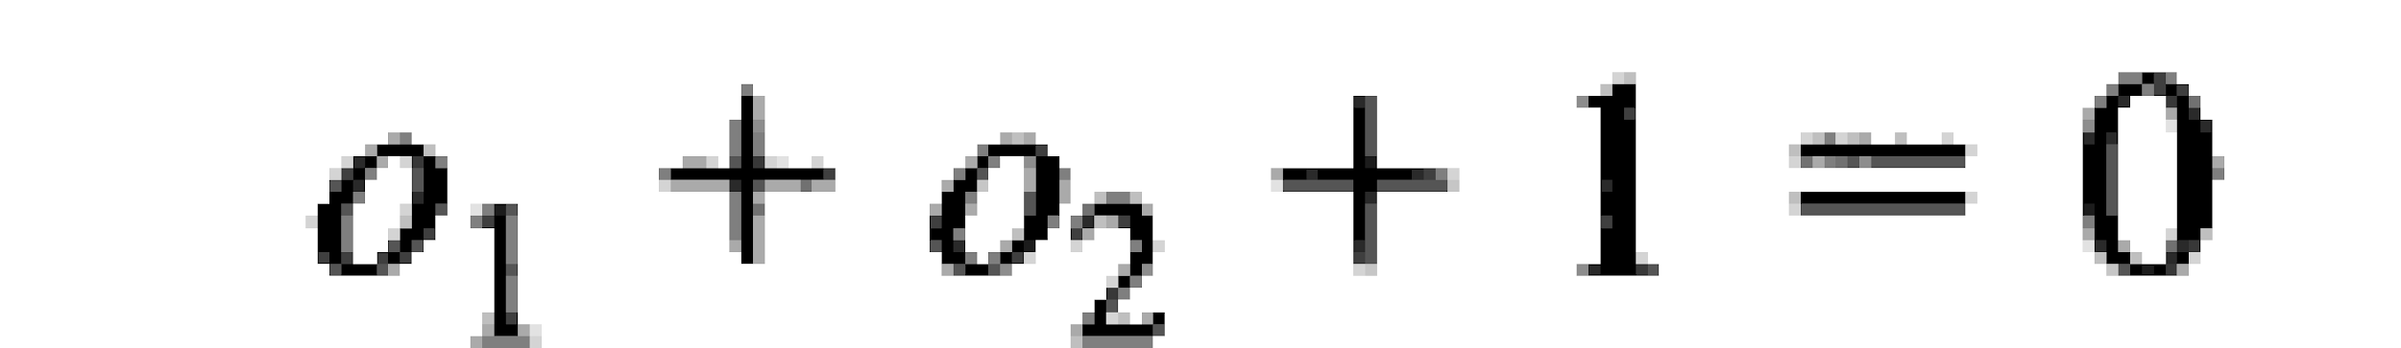

Mapping performed by output perceptron

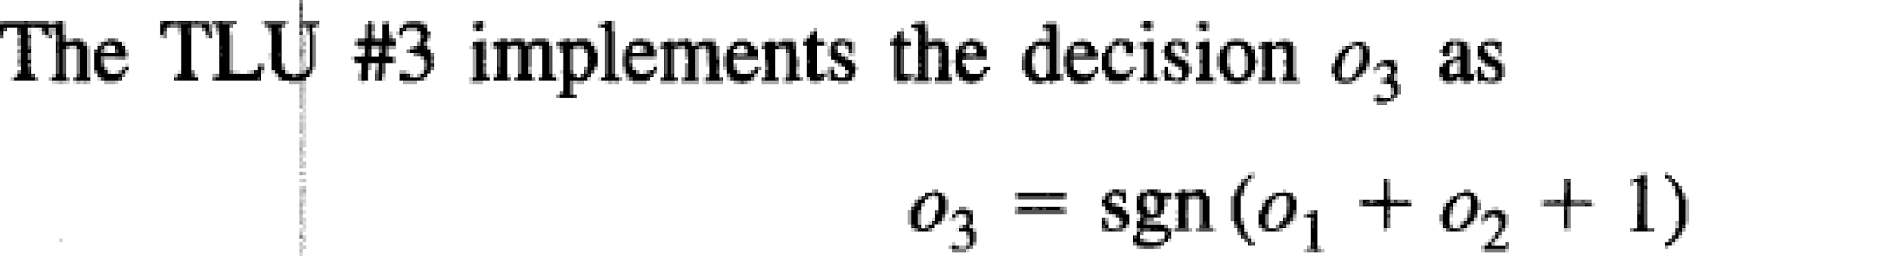

Classification summary table
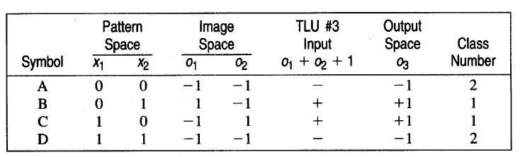

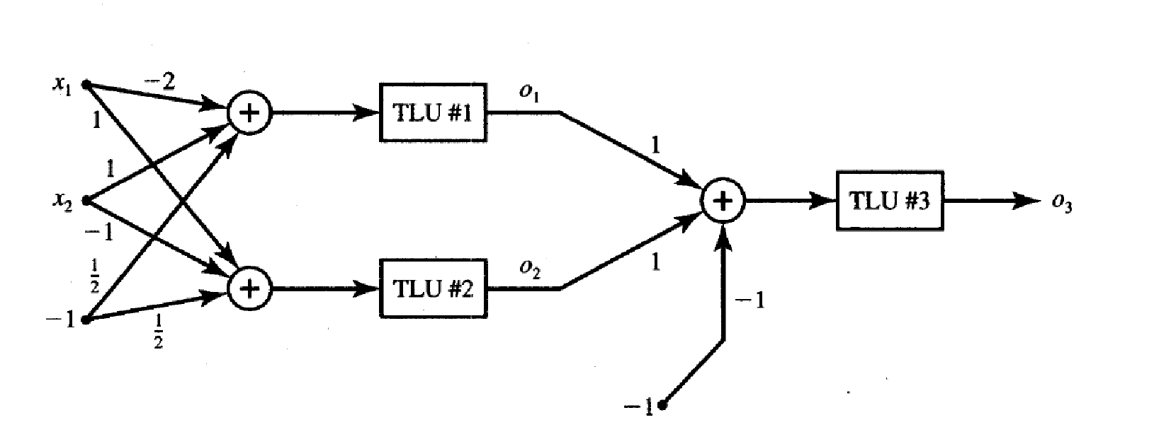
Classifier using Multi-layer Perception Network for implementing XOR logic for 2 inputs.

(Ref. Zurada, Chapter 4)

Code:

import numpy as np

input_vector = [(0,0), (0,1), (1,0), (1,1)]
bias = -1/2

# TLU 1
w1 = -2
w2 = 1
o1_vector = []
for input in input_vector:
x1, x2 = tuple(input)
net = x1*w1 + x2*w2 + bias
o1 = int(np.sign(net))
o1_vector.append(o1)

# TLU 2
w1 = 1
w2 = -1
o2_vector = []
for input in input_vector:
x1, x2 = tuple(input)
net = x1*w1 + x2*w2 + bias
o2 = int(np.sign(net))
o2_vector.append(o2)

# TLU 3
w1 = 1
w2 = 1
bias = 1
o3_vector = []
class_vector = []
for i in range(len(input_vector)):
o1 = o1_vector[i]
o2 = o2_vector[i]
net = o1*w1 + o2*w2 + bias
o3 = int(np.sign(net))
o3_vector.append(o3)
if o3 > 0:
class_vector.append(1)
else:
class_vector.append(2)

x1_vector = [i[0] for i in input_vector]
x2_vector = [i[1] for i in input_vector]
output = list(zip(x1_vector, x2_vector, o1_vector,o2_vector,o3_vector, class_vector))

print("------------------------------------------------------------------")
print("Pattern Space\t | Image Space\t | Output Space\t | Class\t |")
print("x1\t | x2 \t | o1\t | o2 \t | o3 \t\t | Number \t |")
print("------------------------------------------------------------------")

for record in output:
for value in record[:4]:
print(value, end = '\t | ')
for value in record[4:]:
print(value, end = '\t\t | ')
print()
print("------------------------------------------------------------------")

Output:
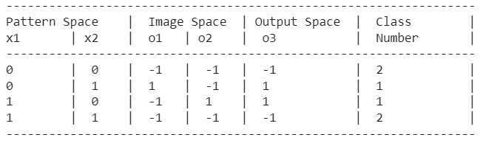

Conclusion: Thus, we have successfully implemented classifier using MLP for linearly non-separable XOR functions of 2 inputs.

Post Lab Descriptive Questions:
- Why is XOR-logic Gate function problem being Linearly non-separable?
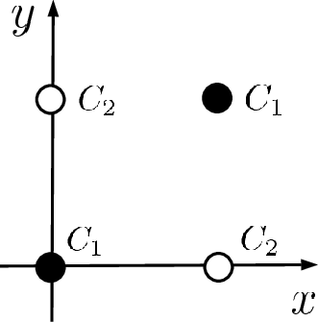
Linear Separability refers to the data points in binary classification problems which can be separated using linear decision boundary. if the data points can be separated using a line, linear function, or flat hyperplane are considered linearly separable.

XOR is not linearly separable as the data points will overlap the data points of the linear line or different classes occur on a single side of the linear line.

There is no way to draw a single line to separate the classes C1 and C2.

- Design a classifier using MLP perceptron model for implementing NOT XOR logic.
import numpy as np

input_vector = [(0,0), (0,1), (1,0), (1,1)]
bias = -1/2

# TLU 1
w1 = -2
w2 = 1
o1_vector = []
for input in input_vector:
x1, x2 = tuple(input)
net = x1*w1 + x2*w2 + bias
o1 = int(np.sign(net))
o1_vector.append(o1)

# TLU 2
w1 = 1
w2 = -1
o2_vector = []
for input in input_vector:
x1, x2 = tuple(input)
net = x1*w1 + x2*w2 + bias
o2 = int(np.sign(net))
o2_vector.append(o2)

# TLU 3
w1 = -1
w2 = -1
bias = -1
o3_vector = []
class_vector = []
for i in range(len(input_vector)):
o1 = o1_vector[i]
o2 = o2_vector[i]
net = o1*w1 + o2*w2 + bias
o3 = int(np.sign(net))
o3_vector.append(o3)
if o3 > 0:
class_vector.append(1)
else:
class_vector.append(2)

x1_vector = [i[0] for i in input_vector]
x2_vector = [i[1] for i in input_vector]
output = list(zip(x1_vector, x2_vector, o1_vector,o2_vector,o3_vector, class_vector))

print("------------------------------------------------------------------")
print("Pattern Space\t | Image Space\t | Output Space\t | Class\t |")
print("x1\t | x2 \t | o1\t | o2 \t | o3 \t\t | Number \t |")
print("------------------------------------------------------------------")

for record in output:
for value in record[:4]:
print(value, end = '\t | ')
for value in record[4:]:
print(value, end = '\t\t | ')
print()
print("------------------------------------------------------------------")

Output:

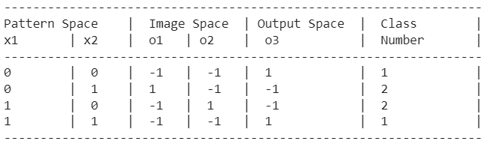

Date: 16/10/2023 Signature of faculty in-charge

